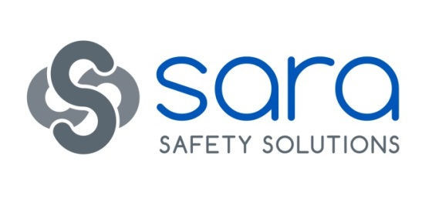
L2 Allergen Awareness in Catering
Course summary:
An informative progressive training course providing specific targeted learning outcomes to increase awareness and confidence in allergen control
Aim:
The aim of this training is to support persons working in a catering environment. It is also to signpost learners to existing allergen resources recommended by the Food Standards Agency and Allergy UK
Objectives of the training:
On completion of the training learners will be able to:
- Identify the risks associated with food allergies and intolerances
- Identify the major food allergens
- Understand the importance of working to procedures to prevent allergen contamination
- Understand the importance of controls, actions, information and communication
- Know where to find further information and resources
LO1 Understand the typical features of food allergies & intolerances & potential risks
1.1 Why it is important to provide accurate allergen information and the implications of not doing so, including:
- Risk of allergy related illness/death.
- Suggested theories as to why food allergies are rising in the UK
- Risk of enforcement actions
- Providing safe food moral and legal responsibility
1.2 Response to and symptoms of allergic reactions and food intolerances, including:
- Typical symptoms of food allergy and intolerance
- Basic information regarding what to do if a customer suffers an allergic reaction, including emergency action for anaphylaxis
1.3 Common food allergens and foods causing intolerances, including:
- Main food ingredients which can cause allergic reactions and food intolerances and illnesses (e.g. Coeliac disease)
- Current allergens required to be identified

LO2 Understand procedures for identifying & controlling allergenic contamination
2.1 Common vehicles of allergenic contamination and appropriate hygiene controls:
- Common vehicles to include hand and food contact surfaces, equipment
- Controls include personal hygiene, cleaning, separation, covering and labelling
2.2 Allergenic cross-contamination hazards and controls:
- Controls at specific process steps to include delivery, storage, preparation, cooking, display and service
- Actions to take if food has been contaminated

LO3 Understanding the importance of information & communication
3.1 Methods of providing accurate allergen information:
- Interpreting labels and recipes
3.2 How allergen information can be provided effectively:
- Written and verbal communication both internally and to customers
- Different ways information may be communicated
- Need to make information available to consumers, importance of information being current and accurate
- Where resources can be found to assist communication

Downloads to support this course:
- Links to FSA Allergen Chart, Chefs Recipe Card & Allergen Signage
- Links to Allergy UK website

